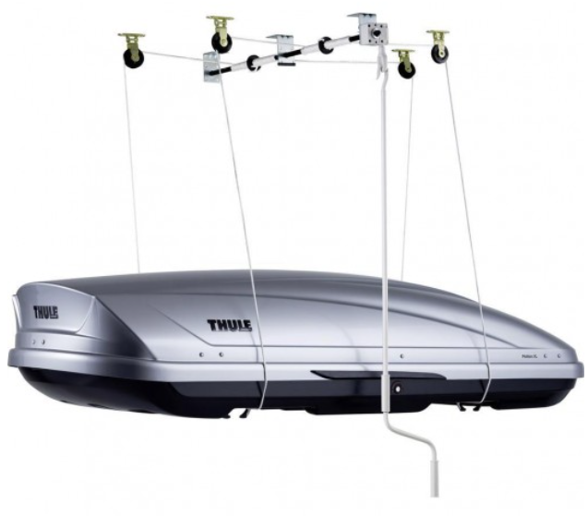

<https://www.obchodth.cz/2836-zvedak-boxu-thule-boxlift-572.html?gclid=EAIaIQobChMI7NWgqaKH9gIVTeN3Ch2x-A0HEAQYAyABEgI3mfD_BwE>